**PHARMACEUTICAL AUTOMATION: REVOLUTIONIZING DRUG MANUFACTURING AND BEYOND**

**ABSTRACT**

Just like any other industry, Automation has revolutionised the pharmaceutical industry too. It has enabled to increase the efficacy, save time, reduce cost and ensure products of consistent quality. In a country like India which is known as the Pharmacy of the world, it is essential that the quality of the medicines is uncompromised and pharmaceutical automation will enable adherence to the same. Automation is used at various stages of Pharmaceutical Industry right from target identification, lead discovery, pre-clinical and clinical trials, manufacturing, packing and labelling. This article provides an insight on the use of automation in each of these areas. Amid rising prescription volumes and increasing expectations for accuracy, safety, and timely dispensing, community pharmacies must adopt automation systems to enhance workflow efficiency and reduce medication-related errors

**Keywords: Automation, Pharmaceutical industry, Robots**

**INTRODUCTION**

It is said that innovation is the key to the future and this has been proved by the introduction of automation. Which has been able to overcome the traditional challenges and meet the growing demands of the Pharmaceutical Industry.

Pharmaceutical automation refers to the use of technology and automated systems to perform various tasks in the pharmaceutical industry, right from drug discovery to its manufacturing, quality control, packaging, labelling, and distribution with minimal human intervention. [1]

Beyond large-scale manufacturing, automation is increasingly transforming community pharmacy practice as well. With rising prescription volumes, expectations for rapid and error-free dispensing, and the need for uninterrupted access to essential medicines, community pharmacies are now integrating automated dispensing systems, smart inventory tools, and digital workflow technologies. These innovations ensure consistent drug availability, reduce human error, and allow pharmacists to devote more time to patient counselling, medication therapy management, and public health services. Thus, automation not only strengthens industrial production but also enhances the quality of pharmaceutical care at the community level.

Technology like artificial intelligence, robotics, Internet Of Things, Cloud computing and automated systems like sensors, programmable logic Controllers, software’s can be used.[2]

Consider for example a tablet coating machine (figure 1), without automation the personnel would have to manually load the tablets in to the coating pan and manually adjust the air flow rate, spraying rate, temperature, and visually inspect the coating uniformity but with the introduction of automation , there are conveyers which will automatically load the tablets into the coating pan, there are sensors and Programmable Logic Controllers (PLC’s). PLC’s are digital computers which are used to control equipment or process. These are used to sense and automatically adjust the spraying rate, airflow rate, temperature and with the help of NIR-Spectroscopy we can do in – line inspection of coating uniformity.

We can also consider the example of sterile operation (figure 2), without automation operators had to manually handle sterile components inside a cleanroom. Vial or ampoule handling was done manually under laminar air flow, in this there was a high risk of contamination due to human presence and intervention and sterility assurance relied heavily on the operators training and aseptic techniques used. But with automation, entire process occurs in Restricted Access Barrier System (RABS) or a isolator. Robotic arms and conveyers handle sterile components without human touch. Vials can be automatically washed, sterilized, filled and sealed. Operator stays outside the isolator and control the process via touchscreens or PLC’s. This minimizes contamination risk and improves sterility assurance.

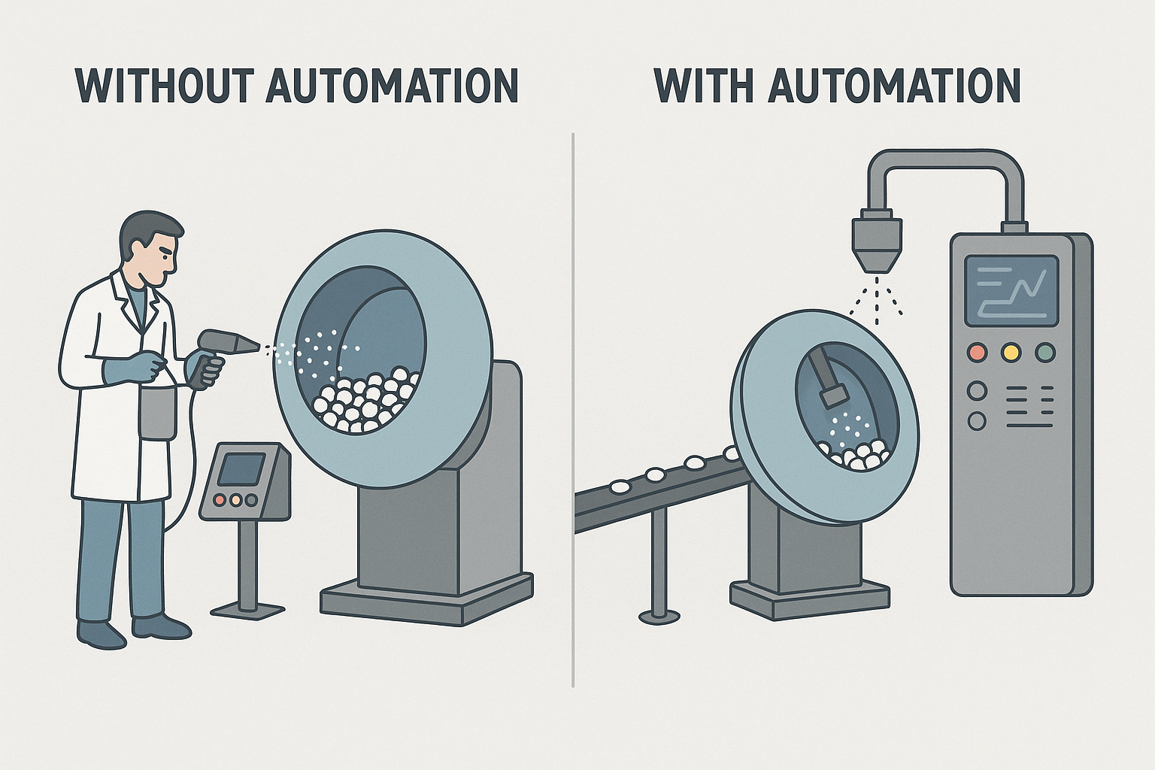

Tablet coating process without and with automation (figure 1)

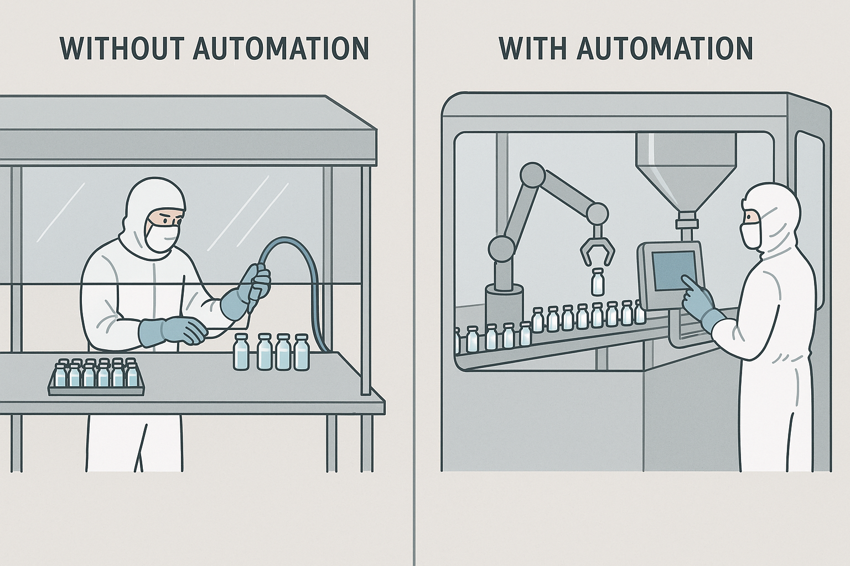

Sterile operation without and with automation (figure 2)

**ADVANTAGES OF AUTOMATION**

Cost reduction

Automation can reduce labour cost thus reducing operation cost. As much of the tasks get automated humans will only be needed for the overall supervision. Although the initial cost of setting up the technology and it’s maintenance is high its benefits are realised during the large scale manufacture.

Increased productivity

Automations helps in completing various tasks in the pharmaceutical industry much more efficiently and also saves time. Automation and robots are used to perform weighing, cleaning, mixing and even documentation. Data analysis can be used to make the best decisions in marketing and expanding the business of the company. Data which would have required days to analyze can now be analyzed and results interpreted in just minutes.

Enhances quality

Industrial automations help in developing products of consistent and reproducible quality. Robots are programmed to perform specific tasks and use of sensors will help to quickly detect any errors if present.

Industrial Safety

Automated systems have reduced direct physical contact of the personnel with the equipment or with the drug. Thus increasing safety of the employees. Loading and unloading of the material, material transfer is now done by machines. Sensors continuously monitor temperature and other parameters and take prompt actions and activate alarm incase of any temperature spikes to ensure safety of the personnel

Reliable outcome

Automation relies heavily on proper data integration and seamless connectivity. When reliable data is incorporated into manufacturing processes, it ensures highly precise outcomes. Technologies like AI and machine learning provide comprehensive data, which can be processed through analytical tools to extract accurate insights.

Monitoring of equipment

Automated systems for equipment monitoring enable continuous supervision of machinery within manufacturing facilities. Using sensors, cameras and network technologies, equipment can be remotely observed. These systems assist in detecting faults and facilitating timely maintenance and repairs. It minimises the need for manual oversight, contributes to improved performance and longevity of the machines. [3, 4]

**DISADVANTAGES OF AUTOMATION**

Worker displacement

One of the most notable drawbacks of automation is the reduction in demand for human labour. Automated system can perform tasks with greater speed and precision than their human counterpart.

High Initial Investment

While automation has long been a cornerstone of industrial progress, it comes with significant financial considerations. Implementing automated systems often requires substantial capital investment not only for installation but also for ongoing maintenance. Furthermore, such systems are increasingly vulnerable to cybersecurity threats, posing risks to operations if proper protective measures are not implemented.

**3. Risk of Obsolescence**

Although automation offers efficiency and convenience, its usefulness can diminish when systems must be adapted to accommodate new changes. Modifying automated processes to meet updated requirements can be time-consuming and resource-intensive, potentially offsetting the productivity gains they were intended to deliver.  
  
4. Continued Need for Human Oversight

Despite advancements in automation, certain operations still necessitate human intervention. Human supervision remains essential to ensure the reliability and safety of automated systems. [3]

**AUTOMATION AT DIFFERENT STAGES OF PHARMACEUTICAL DEVELOPMENT**

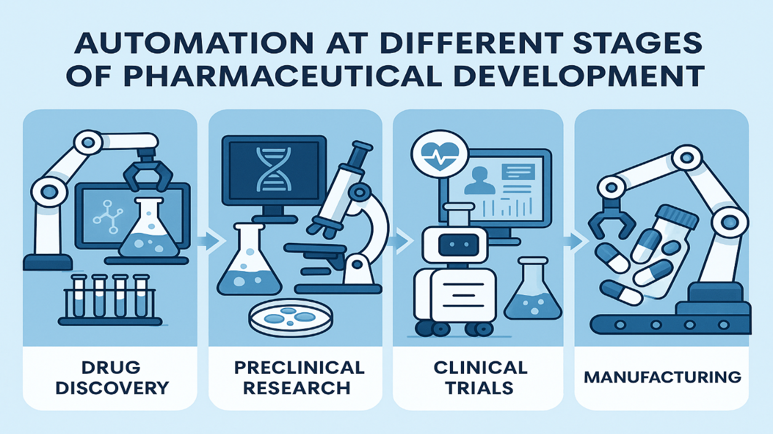

*figure 3*

Prediscovery or Target discovery

During prediscovery or target discovery we attempt to understand the disease, the mechanism of the disease and the biochemical changes that occur in the body during the disease condition. We try to identify the target which can be a receptor, enzyme. This target plays a role in treatment of the disease.

Omics technology is one of the techniques used in target identification. Omics is the study of the roles, relationships and actions of the various types of biomolecules that make up an organism. Depending upon the type of biomolecule under study omics field is categorized into – Genomics, Transcriptomics, proteomics, metabolomics (Table 1).

Table 1

|  |  |  |
| --- | --- | --- |
| **Omics field** | **Focus molecule** | **Use in Target identification** |
| Genomics | DNA | Identify genetic mutations |
| Transcriptomics | RNA | Compare gene expression in healthy tissue and disease tissue |
| Proteomics | Protein | Biomarker discovery |
| Metabolomics | Metabolite | Metabolic pathway study |

Automation is used at various stages like during sample preparation liquid handling robots are used, Magnetic bead based system is used to separate nucleic acids in the sample, Mass Spectrometry is used for protein and metabolite identification. Use of Microarray technology, Microarrays analyze thousands of genes in one experiment. Not only the change in gene expressions but also mutations in DNA are measured. Bioinformatics tools like BLAST are also used to compare biological sequences of DNA, RNA, proteins to identify similar sequences in database. [5,6]

**DRUG DISCOVERY**

During drug discovery suitable lead molecules are identified, lead is a molecule which is having the desired therapeutic activity but requires structural modification for its optimisation. These lead molecules can interact with the biological target involved in the disease and exhibit its pharmacological action.

Ultra High Throughput Screening (uHTS) is used to screen more than 100,000 of sample molecules against the specific target, to identify the molecules which are most likely having affinity towards the target. [6,7]

Techniques like X – ray crystallography, NMR, homology modelling have aided in the identification of the 3 dimensional structure of the biological target which directs the design of the lead molecule.

In the drug designing, the in silico analysis has been performed using Windows operating system which is implemented with Maestro Software package. This package was provided by Schrodinger, implementing the desired modules Glide, Phase, LigPrep and Quik prop.[1]

**PRE – CLINICAL AND CLINICAL TRIALS**

Table 2

|  |  |
| --- | --- |
|  | Name of the software |
| In Pre-clinical trials | Electronic data capture |
| In Pre-clinical trials | Remote data capture |
| In Pre-clinical trials | Electronic case report form (eCRF) |
| In Clinical trials | eClinical |
| In Clinical trials | Oracle clinical |
| In Clinical trials | Clinical conductor clinical trial management system (CTMS) (by Bio-Optronics) |
| In Clinical trials | Clindex |
| In Clinical trials | Ascend (by Biopharm) |

Softwares are used to randomize the test subjects and to plan the study design. Various software are used in clinical and pre clinical trial they help in data collection, data management, analyzing , interpreting the data and statistical analysis. Big Data Management (BDM) technology offer advanced tools which help in efficient storage, retrieval, utilization of medical records and follow up information.[1]

**RESEARCH AND DEVELOPMENT**

In virtual research and development, In silico experiments are carried out. An example of software package used is Formulation Computer Aided Design (F-CAD), which is based on the concept of cellular automata and can calculate the dissolution profile of the drug product on the basis of the chemical composition and the physicochemical properties of the drug and the excipients.

the technology of robots that possess the electro-mechanical system are used to perform tasks like mixing , weighing , testing.[1]

**PRODUCTION AND MANUFACTURING**

Automation in the manufacturing can be of three types Fixed (hard) automation, flexible and programmable automation.

Fixed automation also called as hard automation, the machines will produce a specific product continuously without any change. So the sequence of operation steps remains the same. For example, Tablet pressing machine in paracetamol production line. Once set, it continuously compresses powder into tablets of the same size, shape and dose. This is particularly useful for companies in bulk production of a specific product.

In flexible automation the system can adapt quickly and automatically to produce different products without stopping the process. Example, A flexible packaging line that can package different blister packs for oval or round shaped tablets or tablets with different dose. So simultaneous packing of two different products is possible. This is achieved through central computing system controlling the robotic arms and labelling.

Programmable automation, the operation of the machine can be changed by reprogramming it. For example, coating machine which performs sugar coating can be reprogrammed to perform film coating as well eg. SanityCo tablet coating machine

Computer Aided Manufacturing (CAM) and Computer Integrated manufacturing (CIM) is used in the product development. Although the two terms sound similar they mean different, Computer Aided manufacturing. In computer aided manufacturing, a specific machine or a process is controlled and automated directly. Eg. Using a CAM system to control a tablet compression or tablet coating machine using a software that will adjust the speed, temperature, pressure as per the formula.

In Computer Integrated Manufacturing system (CIM), the entire manufacturing process right from the design, planning, production, Quality control, inventory and documentation is integrated through computers. This will enable all the departments work together digitally for better efficacy and coordination.

More advanced automated manufacturing system are Intelligent manufacturing, Virtual manufacturing, Internet controlled manufacturing

Intelligent manufacturing also known as smart manufacturing, it will make use of real time data using intelligent sensors, artificial intelligence, machine learning, and have decision making ability. Smart controllers enable self-control of the manufacturing process.

Virtual Manufacturing software are used to create simulation of the manufacturing process, that will enable us to create and test the product before it is actually made in the real world. This is a great tool that will enable us to identify the errors, save time and money. Example of such softwares are Siemens Tecnomatix, AutoMod, LexSim Healthcare.

Internet controlled manufacturing, IoT (Internet of Things), which is a network of objects or things which are interconnected, transfer data and capable of cross device communication. This will enable remote monitoring and control of manufacturing operation and equipment.[1,2,8]

**CASE STUDY**

Two companies Invetech and Argos Therapeutics worked together to make an automated system for personalized immunotherapy based on Argos’ Arcelis Technology (figure 4). Tumor cells are collected from the patient, scientist will extract the tumor DNA and use this as template to generate mRNA using two robotics arms, this mRNA acts as a antigen and is loaded in the white blood cells of the patient, these WBC’s are extracted and their growth and maturation into dendritic cells is controlled in a cellular automated equipment. Dendritic cells are specialized immune cells which present the antigen on their surface and when they are introduced into the body of the patient, they will trigger the immune response to produce T-lymphocytes against the tumor cells. [9]

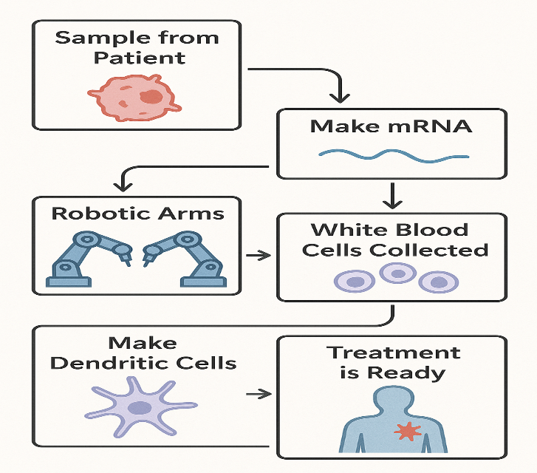

Invetech using argos’ arcelis technology to make personalized treatment (Figure 4)

**PACKING AND LABELING**

Modified atmosphere packing technique is used to artificially reduce oxygen level and increase carbon dioxide level, smart packaging use nanotechnology sensors to detect microbial and any other contamination.

To detect counterfeit products in the market the product is given a unique identification code. This can be in the form of bar code, QR code or something more advanced like a RFID (Radio Frequency Identification) tag (figure 5). This tag is applied to the product container. When the scanning device or the reader sends radio signals, these will be received by the radio tag and will communicate back by sending information like the name of the product, batch number, expiry date. This is a great tool to identify fake products in the market. [1,10,11]

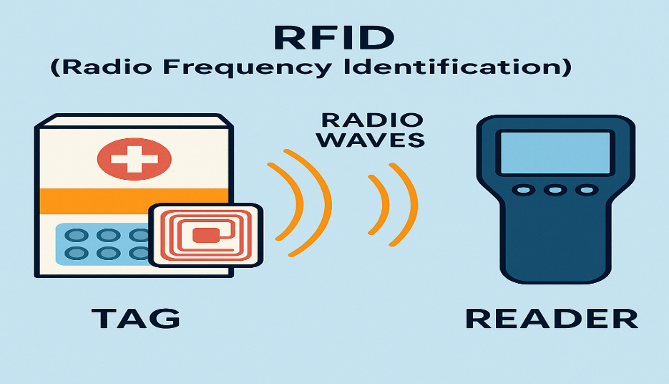

RFID technology (figure 5)

**AUTOMATION IN HOSPITAL PHARMACY**

Automated dispensing cabinets (ADCs)

ADCs are machines placed near patient care areas like wards or ICUs to store and dispense medication. Even though the pharmacy staff fills these machines with the medicine, nurses and other healthcare providers are usually the ones who select and take out medicines from these machines to give the patient. Thus ADCs help to bring medicines closer to patients bedside. Nurses or the health care provider must login with a password, fingerprint or ID card to assure only authorized access. Once logged in the system will show only the medicines ordered for a particular patient, and highlight the drawer containing the medicine to reduce selection error. ADCs track how many doses are taken by each patient and also can alert the pharmacy when the stocks are low or if any medication is close to expiry. Every dispensing action is electronically recorded.[12]

**CONCLUSION**

Industrial automation is an ongoing process with new technology and innovations transforming the landscape of healthcare. With the growing populations there is an ever-increasing demand for cost effective and high quality medicines. Automation integrated with the other technological advancements like robotics, artificial intelligence is revolutionizing the pharmaceutical industry right from drug discovery to its manufacture, quality control and dispensing. This is ensuring that medicines are produced in highly time efficient manner, also enabling discovery of new medicines with better efficacy and minimize errors which directly impact quality of the treatment the patient receives.

**REFERENCES**

1. Mannan AB, Mubeen HA. Digitalisation and automation in pharmaceuticals from drug discovery to Drug Administration. Int J Pharm Pharm Sci. 2018;10(1).
2. Lei Y, Su Z, He X, Cheng C. Immersive virtual reality application for intelligent manufacturing: Applications and art design. Mathematical Biosciences and Engineering. 2023;20(3):4353-87.Mannan AB, Mubeen HA. Digitalisation and automation in pharmaceuticals from drug discovery to Drug Administration. Int J Pharm Pharm Sci. 2018;10(1).
3. Gandu S, Gandla K, Vaishnavi M, Repudi L. A review on implementation of automation in the pharmaceutical industries. World Journal of Advanced Research and Reviews. 2023;18(2):606-15.
4. Kungu E. Automation in drug manufacturing: ensuring quality and safety. Res Invention J Sci Exp Sci. 2025;5(1):57–61. Available from: https://doi.org/10.59298/RIJSES/2025/515761
5. Karahalil B. Overview of systems biology and omics technologies. Current medicinal chemistry. 2016 Nov 1;23(37):4221-30.
6. Hemamalini V, Tyagi AK, Vasuki P, Kumari S. Industrial automation in drug discovery: the emerging of smart manufacturing in Industry 5.0. InConverging Pharmacy Science and Engineering in Computational Drug Discovery 2024 (pp. 159-176). IGI Global.
7. Entzeroth M, Flotow H, Condron P. Overview of high‐throughput screening. Current protocols in pharmacology. 2009 Mar;44(1):9-4.
8. Popovic D. Automation and control in production processes, Control systems, robotics and automation. Industrial Appl Control System 2009;19:1-10.
9. Khan MY, Gavit A. Automation and robotics in pharmaceutical industry. Int J Pharm Res Appl. 2024 May-Jun;9(3):115–32.
10. Alagarsamy S, Kandasamy R, Subbiah L, Palanisamy S. Applications of internet of things in pharmaceutical industry. Available at SSRN 3441099. 2019 Aug 22.
11. Salunke SB, Wasmate DN, Bawage SB. Automation in pharmaceutical industry. World Journal of Pharmaceutical Research. 2022 Mar 2;11(3):1864-77.
12. M. Boyd A, W. Chaffee B. Critical evaluation of pharmacy automation and robotic systems: a call to action. Hospital pharmacy. 2019 Feb;54(1):4-11.
13. Ramamoorthy SP. Role of AI, Automation & Robotics in Pharmaceutical Industry. Journal of Next-Generation Research 5.0. 2024 Dec 8.
14. Anagnoste S. Robotic process automation in pharma: three case studies. InConference: BASIQ 2018
15. Shinde A, Pawar D, Sonawane K. Automation in pharmaceutical sector by implementation of artificial intelligence platform: a way forward. International Journal of Basic & Clinical Pharmacology. 2021 Jul;10(7):863-9.